- First you will need to create an account
- Make sure you are creating a free account
Creating a Presentation:
- The Dashboard is where your powtoons will be stored. You can go back here to edit them anytime.
- To create a new powtoon, click on the blue “create” button (see picture below).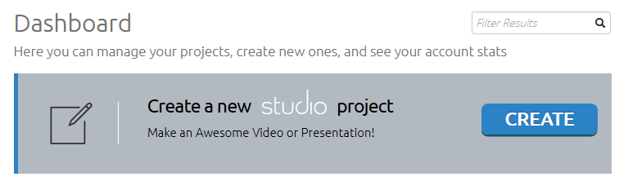
- You can either choose a ready-made powtoon to edit, or you can start from scratch.
- Make sure you do not choose one with “premium” or “business” on it as these cost money.

Editing Basics:
- Once you have chosen a background an editing window will open and a tutorial will pop up explaining the editing basics.
- On the right side, you have a tool bar. You can add characters, props, backgrounds, shapes, text boxes, etc.
- Different themes will have different items you can choose.
- You can also add your own images you have saved on the computer.
- You can customize the motion and timing of each icon you add. Click on the icon and use the time bar at the bottom.
- Add new slides on the left side and the plus sign between them is for transitions between slides.
Adding sound:
- Click on the sound icon on the right side.
- You can add music (“soundtrack”)
  - Powtoons has some music you can choose
  - You can import your own music – use Soundzabound.com for tons of free music downloads
- You can add a voice over in 2 ways
  - From beginning to end (continuous)
  - Slide by slide
Embedding Video:
- You must be in slideshow mode to embed a video (top left corner of your powtoons (see picture)
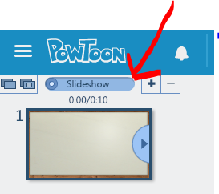
- You can upload a video from your computer to embed in your powtoons.
- You can also search Youtube or insert the url to your Youtube video

*When your presentation is complete, you will need to export it to get the URL to share with your teacher
*You can get the sharing url from your Dashboard videos
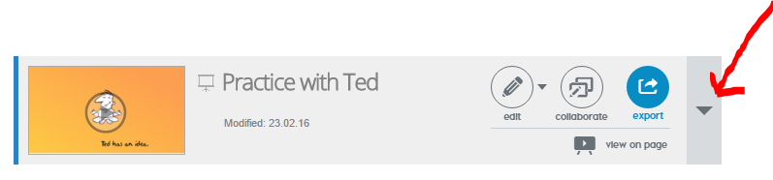
- Click on the down arrow to expand the powtoon

- Scroll down under the video for the sharing link.
